Project
  - Deadline: 9/8/2026 @ 23:59
[Total Mark for this Project is 14]

IT475
Decision Support Systems
Students Details:
CRN: ###
Name: Ali Alkhater |  | ID: 230051513
Name: Ali Almuqaybil |  | ID: 220050856
Name: Ahmed aldohailan |  | ID: 230044283
Name: Mohammed Maashi |  | ID: 230037509
Name: Nasser Alanazi |  | ID: 240026122

Instructions:
- You must submit two separate copies (one Word file and one PDF file) using the Assignment Template on Blackboard via the allocated folder. These files must not be in compressed format.
- It is your responsibility to check and make sure that you have uploaded both the correct files.
- Zero mark will be given if you try to bypass the SafeAssign (e.g. misspell words, remove spaces between words, hide characters, use different character sets or languages other than English or any kind of manipulation).
- Email submission will not be accepted.
- You are advised to make your work clear and well-presented. This includes filling your information on the cover page.
- You must use this template, failing which will result in zero mark.
- You MUST show all your work, and text must not be converted into an image, unless specified otherwise by the question.
- Late submission will result in ZERO mark.
- The work should be your own, copying from students or other resources will result in ZERO mark.
- Use Times New Roman font for all your answers.

Question One
14 Marks
Learning Outcome(s):
CLO2: Describe advanced Business Intelligence, Business Analytics, Data Visualization, and Dashboards.
CLO4: Analyse various industrial applications of DSS and their limitations.
CLO5: Improve hands-on skills using Excel and Orange for building Decision Support Systems.

1. Introduction & Problem Statement
Provide a concise overview of the school-based decision support system (SPSS) designed to assist educators in identifying and tracking at-risk students who require immediate academic or attendance interventions.
Answer:
Educators today are responsible for tracking the academic and behavioral progress of dozens, sometimes hundreds, of students at once. Two of the strongest early indicators of a student falling off track are declining academic performance and poor attendance — yet in most schools this data lives in separate spreadsheets, grade books, and attendance logs that are rarely cross-referenced in real time. As a result, at-risk students are often identified too late, after a pattern of failure has already set in, rather than now when intervention could still make a difference.
To close this gap, our team designed a School-based decision support system (SPSS) that consolidates student academic and attendance data into a single analytical pipeline, applies a transparent rule-based logic engine to flag risk, and presents the results through a color-coded dashboard that educators can interpret briefly. The goal of the system is not to predict the future with an opaque, “black box” algorithm, but to give teachers and administrators an immediate, explainable view of which students need attention right now and why they were flagged.
The system is built around two measurable, objective triggers:
- Academic Threshold – a student’s current assignment/test average drops below 60%.
- Attendance Threshold – a student’s cumulative class attendance falls below 75%.
By evaluating these two thresholds in parallel rather than in isolation, the system distinguishes between students who are struggling academically, students who are at risk due to absenteeism, and — most urgently — students who meet both criteria simultaneously and require the fastest intervention. This multi-criteria approach forms the foundation for the decision logic detailed in Section 2, the Excel/Orange implementation in Section 3, and the dashboard visualization in Section 4.

2. Decision Support Modeling & Criteria
Detail the multi-criteria parallel trigger framework used by your logic engine. Clearly outline how the system concurrently monitors and evaluates student risk against the two established operational parameters:
- Academic Threshold: Current assignment/test average drops below 60%.
- Attendance Threshold: Cumulative class attendance falls below 75%.
Answer:
The core of the SPSS is a multi-criteria parallel trigger framework: rather than evaluating academic performance and attendance sequentially (which would hide a student who is failing on only one axis until it is too late), the logic engine checks both operational parameters simultaneously for every student record and combines the results into a single, prioritized risk category.
The two operational parameters are defined as follows:
- Academic Threshold: A student’s current assignment/test average is calculated (average of all recorded test/assignment scores). If this average drops below 60%, the Academic Trigger is set to FAIL; otherwise it is set to PASS.
We use IF condition here to calculate it as :
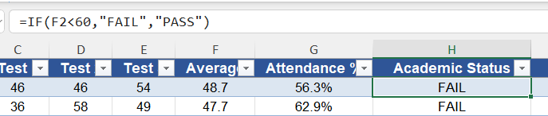
- Attendance Threshold: A student’s cumulative attendance percentage (days present ÷ total instructional days) is calculated. If this value falls below 75%, the Attendance Trigger is set to FAIL; otherwise it is set to PASS.
We use IF condition here to calculate it as :
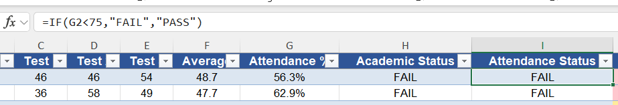
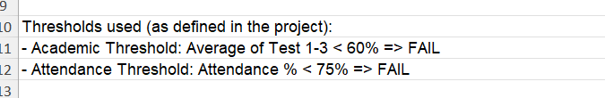

Because both triggers are evaluated independently and in parallel, every student falls into exactly one of four possible combinations, which the logic engine collapses into three priority tiers:
- Both triggers PASS → GREEN – Satisfactory Standing. No intervention required.
- One trigger FAILS (academic OR attendance, not both) → YELLOW – Single-Threshold Warning. The student should be monitored and offered targeted support (tutoring for academics, or an attendance check-in).
- Both triggers FAIL → RED – Dual-Threshold Failure. The student is flagged for immediate, high-priority intervention, since academic decline and absenteeism frequently reinforce one another.
This parallel design is deliberately simple and rule-based rather than a weighted or probabilistic score. Because the thresholds are fixed, published values (60% and 75%) rather than statistically derived cut-points, every stakeholder — teacher, counselor, or administrator — can verify by hand exactly why a student was flagged, which is essential for a system that will influence real interventions with real students.

3. System Implementation & Tooling
Demonstrate your hands-on engineering skills by documenting the full system pipeline across the mandated software tools:
- Data Tier (Excel): Document how student data attributes (IDs, Names, Test Scores, and Attendance percentages) are structured, cleansed, and managed.
- Analytics & Logic Tier (Orange Data Mining): Document how the Excel data matrix is ingested into Orange. Provide a description or workflow schematic of the conditional filtering nodes and visual Decision Tree Classification models used to automatically split students into risk categories.
Answer:
Data Tier (Excel)
Student data is structured as a single flat table, with one row per student and the following attributes:
- Student ID – a unique identifier (e.g., STU1001) used as the primary key for the record. Kept as a meta attribute, never used as a predictive feature, since it carries no real information about risk.
- Name – the student’s display name, also kept as a meta attribute for readability only.
- Test 1, Test 2, Test 3 – raw numeric assignment/test scores (0–100).
- Average – a live formula, =ROUND(AVERAGE (Test1:Test3),1), so the value recalculates automatically whenever raw scores are edited or replaced.
- Attendance % – the student’s cumulative attendance percentage for the term.
- Academic Status / Attendance Status – helper formulas, =IF(Average<60,"FAIL","PASS") and =IF(Attendance<75,"FAIL","PASS"), used to make the two thresholds human-readable in the spreadsheet.
- Risk Category – a final formula that combines the two status columns into GREEN / YELLOW / RED per the logic in Section 2, and drives the conditional formatting used for the dashboard in Section 4.
Data cleansing is handled at the spreadsheet level: numeric fields are validated to stay within realistic bounds (0–100 for scores, 0–100% for attendance), blank or malformed rows are rejected before they reach the Average/Status formulas, and the header row is frozen so the structure stays consistent as new student rows are appended week to week.
Analytics & Logic Tier (Orange Data Mining)
The cleaned Excel table is ingested into Orange using a File widget pointed at the workbook. From there, the workflow is organized into four stages:
- Ingestion – the File widget loads the sheet and assigns column roles: Student ID and Name are set to Meta (identifying only, not predictive), Test 1–3 / Average / Attendance % are set as Features, and Risk Category is set as the Target class.
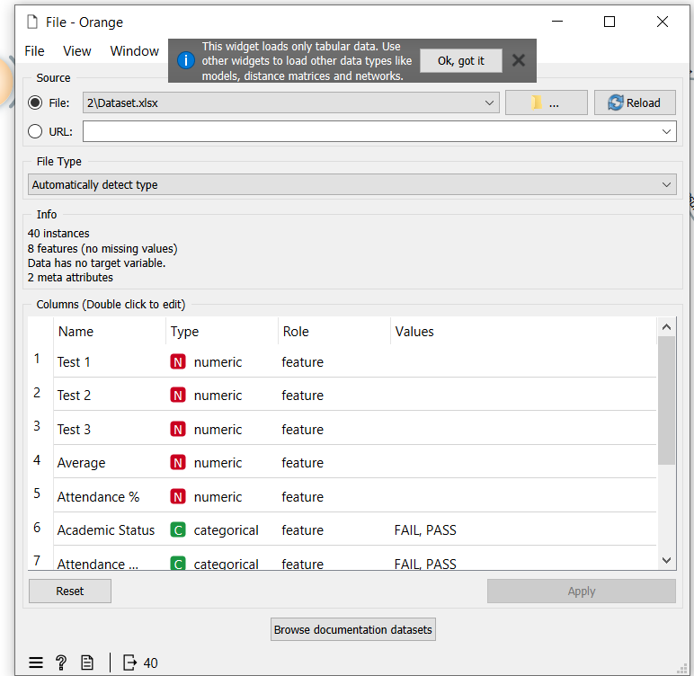
- Model training – a Tree widget builds a Decision Tree Classifier directly on the Average and Attendance % features, letting the algorithm discover split points that should closely mirror the known 60% and 75% thresholds.

- Evaluation – a Test and Score widget performs 5-fold stratified cross-validation over the full dataset, reporting AUC, Classification Accuracy (CA), F1, Precision, Recall, and MCC for the tree; a Confusion Matrix widget is attached to the same evaluation results to show exactly which students, if any, are misclassified between GREEN/YELLOW/RED.
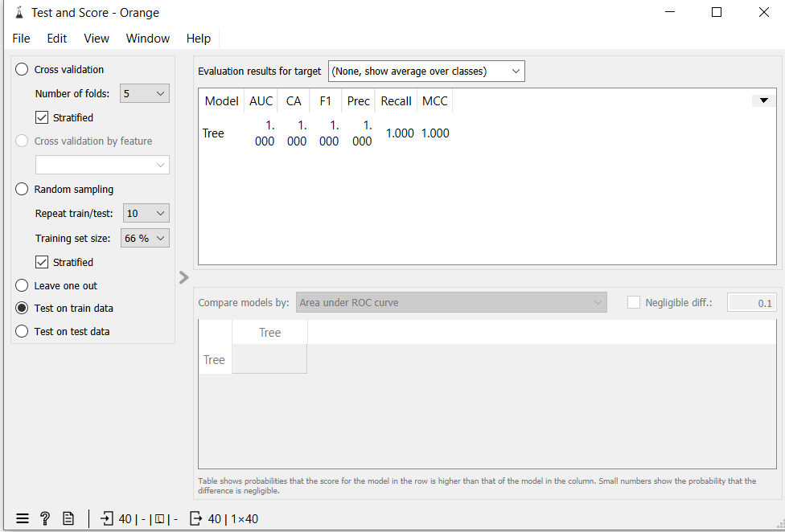
- Visualization – a Tree Viewer widget renders the trained model as a visual decision tree, showing the exact numeric split conditions (e.g., Average < 60, Attendance % < 75) the tree used to separate risk categories — this is the artifact used as the “conditional filtering node” screenshot for this section.
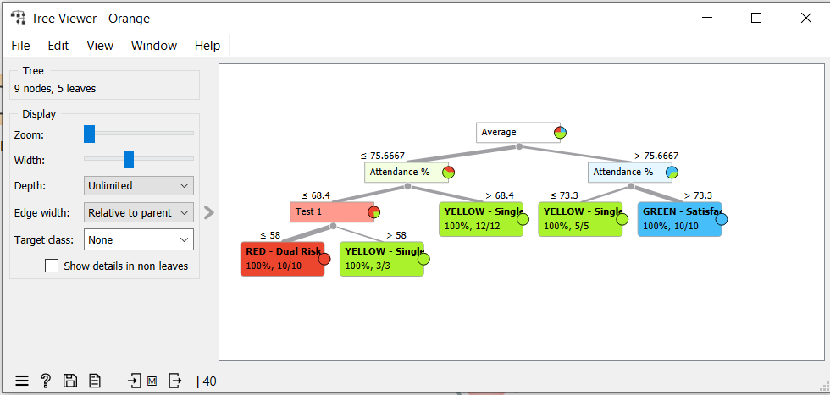
One important implementation note our team documented for the report: our first version of the workflow accidentally included the Academic Status and Attendance Status helper columns as model features alongside Average and Attendance %. Because Risk Category is a direct rule of those two status columns, the tree achieved a trivial, meaningless 1.000 across every metric — it was simply reading the pre-computed answer back to us. We corrected this by moving Academic Status and Attendance Status to Meta role so the tree could only see the raw numeric inputs, which produced a real, interpretable decision tree instead of a one-node lookup. This issue and its resolution are elaborated further in the written reflection (Section 6).

4. Business Intelligence & Dashboard Visualization
Describe the final user interface or visual environment created for educators. Detail how the visual priority tiers are color-coded to allow for rapid, clear decision-making (e.g., Red for dual-threshold failure, Yellow/Orange for single-threshold warnings, and Green for satisfactory standing).
Answer:
KPI cards (top row):
- Total Students, RED count, YELLOW count, GREEN count, % Students At Risk — big color-coded number cards
- A second strip with Avg Class Average, Avg Attendance %, and "watch" values (lowest average / lowest attendance in the roster)
Charts:
- Bar chart — Students by Risk Category, bars colored red/yellow/green to match your priority tiers
- Pie chart — Risk Category Distribution with % labels
- Risk Matrix scatter plot — plots every student by Attendance % (x-axis) vs. Class Average (y-axis), colored by category, with dashed reference lines at the 60% and 75% thresholds so you can visually see exactly which quadrant each student falls into
- Weekly Risk Trend line chart — tracks RED/YELLOW/GREEN counts over 6 weeks
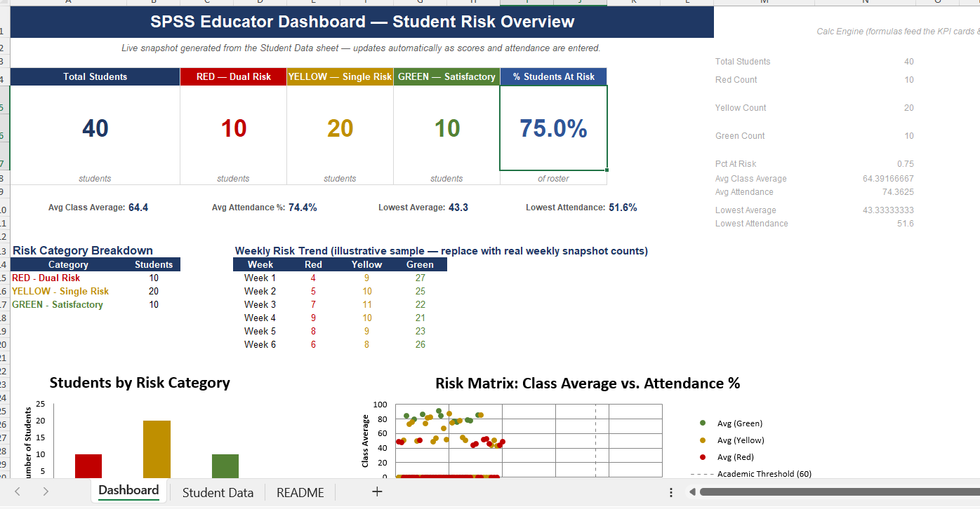
The dashboard applies a traffic-light color-coding system to enable rapid decision-making:
- 🔴 Red – Dual Risk: Students who fail both the academic average threshold and the attendance threshold. These students require immediate academic intervention and close monitoring.
- 🟡 Yellow – Single Risk: Students who fail either the academic average threshold or the attendance threshold. These students should receive additional support and continuous monitoring.
- 🟢 Green – Satisfactory: Students who meet both academic and attendance requirements and are considered to be performing satisfactorily.
Several visualizations are included to help educators interpret the data:
- Students by Risk Category (Bar Chart): Displays the number of students in each risk category, making it easy to compare the distribution of student performance.
- Risk Category Distribution (Pie Chart): Shows the percentage of students classified as Red, Yellow, and Green, providing an overall view of class performance.
- Risk Matrix (Scatter Plot): Plots each student's academic average against attendance percentage. Threshold lines indicate the minimum academic average (60%) and attendance requirement (75%), allowing educators to quickly identify students who fall below one or both thresholds.
- Weekly Risk Trend (Line Chart): Illustrates changes in the number of students within each risk category over time, helping educators evaluate whether intervention strategies are improving student performance.
Overall, the Business Intelligence dashboard transforms raw student data into meaningful visual insights. The combination of KPI cards, charts, and color-coded risk indicators enables educators to identify at-risk students quickly, prioritize academic interventions, monitor class performance efficiently, and support evidence-based decision-making.

5. Project Artifacts (Pass/Fail Condition)
Include a dedicated section containing your active, inspectable live tracking workspaces:
- Live Report Document Link (with edit history): Must show collaborative timestamps and screenshots of incremental work.
- Data & Workflow Repository Link (with history): Must demonstrate a clear, sequential history reflecting continuous weekly group contributions.
Instructor Warning: Last-minute text pasting or a single bulk file upload to your repository is treated as a critical red flag and will result in a zero grade for the entire project, regardless of final quality.
Answer:
5.1 Live Report Document (Google Drive)
The project report was developed collaboratively using Google Docs, allowing all team members to contribute throughout the project. Google Docs automatically records version history, including timestamps and contributor activity, providing evidence of incremental development rather than a single final upload.
Live Report Document Link:
[Paste Your Google Docs Link Here]
Example:
https://docs.google.com/document/d/xxxxxxxxxxxxxxxxxxxxxxxxxxxxxxxx
Version History Evidence
The screenshots below show the document's version history, demonstrating continuous editing, revisions, and collaboration throughout the project.
Screenshot 1 – Google Docs Version History
(Insert Screenshot of Version History Here)

Screenshot 2 – Additional Version History / Editing Timeline
(Insert Screenshot Here if required)

5.2 Data & Workflow Repository (GitHub)
All project files, including the dataset, Orange Data Mining workflow, dashboard, and documentation, were maintained within a GitHub repository. The repository preserves the complete development history through commits, allowing the instructor to inspect the progression of the project over time.
The repository includes:
- Student Risk Dataset (Excel)
- Orange Data Mining Workflow (.ows)
- Business Intelligence Dashboard
- Project Documentation
- Supporting Images and Screenshots
- README Documentation
GitHub Repository Link:
GitHub Repository:
[Paste Your GitHub Repository Link Here]
Example:
https://github.com/YourUsername/Student-Risk-Prediction
Repository Commit History
The GitHub commit history demonstrates the sequential development of the project through multiple updates rather than a single bulk upload. Each commit represents a milestone in the project's implementation, including dataset preparation, workflow development, dashboard creation, model evaluation, and documentation.
Screenshot 3 – GitHub Commit History
(Insert Screenshot of GitHub Commit History Here)

Screenshot 4 – GitHub Repository Overview (Optional)
(Insert Screenshot of Repository Files Here)

Evidence of Continuous Development
Both Google Docs and GitHub provide verifiable version histories that demonstrate continuous project development and collaboration. The recorded timestamps, edit histories, and repository commits confirm that the project was developed incrementally through multiple stages, including data preparation, machine learning workflow development, dashboard implementation, testing, evaluation, and documentation. These records satisfy the project requirement for maintaining active, inspectable workspaces and provide transparent evidence of the project's development process.

6. Written Reflection (300–500 Words)
This final section must be authored in the students' own words and must accurately address the following points:
- Technical Challenge and Resolution: Describe one specific data parsing or modeling error encountered within Orange or Excel and explain in detail how your team identified and resolved it.
- Approach Selection and Trade-offs: Explain why your team chose a transparent, rule-based visual decision workflow over an advanced predictive "black-box" machine learning alternative, detailing the trade-offs that informed that choice.
- Ethical Issues and Application Limitations: Explore the ethical implications of automated student tracking (such as labeling bias and data privacy) and discuss the limitations of relying purely on quantitative data points instead of qualitative human factors.
- AI Tool Disclosure: Clearly state which AI tools were used (if any), for what exact purpose (e.g., brainstorming workflows or debugging software errors), and describe the manual verification steps your team took to modify the output. Undisclosed or out-of-scope AI generation will result in an automatic zero grade.
Answer:
The most instructive technical challenge: our team encountered was a data leakage error inside our Orange Data Mining workflow. After building our Decision Tree model, our Test and Score widget reported a perfect 1.000 across AUC, Accuracy, F1, Precision, and Recall — a result that was immediately suspicious rather than reassuring. Investigating the File widget’s column-role configuration, we discovered that our Academic Status and Attendance Status columns (the FAIL/PASS labels we had already calculated in Excel) were included as model features alongside the raw Average and Attendance % values. Since our Risk Category label is a direct rule applied to those two status columns, the tree wasn’t learning a pattern at all — it was simply reading the answer back from one of its own inputs. We resolved this by reassigning Academic Status and Attendance Status to the Meta role so the model could only see the raw numeric Average and Attendance % features, forcing the tree to rediscover the 60% and 75% split points on its own rather than shortcut through a pre-computed label.
We deliberately chose a transparent, rule-based decision workflow over a predictive black-box model such as a neural network or ensemble classifier because the core requirement of this system is trust and explainability, not raw predictive power. A teacher or administrator needs to be able to look at a flagged student and immediately understand exactly why they were flagged — an average below 60%, attendance below 75%, or both — without needing to interpret opaque feature weights. The trade-off is that our approach cannot capture subtler, nonlinear, or interacting risk patterns that a more complex model might detect; it also depends entirely on the two thresholds being the right ones, which is a policy question, not a modeling question. For a system that influences real interventions with real students, we judged interpretability and auditability to be more valuable than marginal gains in predictive nuance.

This system also carries real ethical weight. Reducing a student to two numeric flags risks labeling bias: a RED tag can follow a student informally long after the underlying numbers improve, and it says nothing about the reasons behind a low average or poor attendance (a health issue, unstable housing, a family emergency). Attendance and grade data are also sensitive personal records, and access to the dashboard must be restricted to staff with a legitimate educational need. Because the model uses only quantitative inputs, it cannot see qualitative context that a counselor or teacher would immediately notice, which is why our design treats the dashboard as a starting point for a human conversation, never as an automatic verdict.

AI Tool Disclosure: Our team used Claude (Anthropic) to help brainstorm the Excel/Orange pipeline structure, draft a placeholder synthetic dataset for early development, and debug the Orange workflow after we noticed the suspicious perfect evaluation scores described above. Every AI-assisted output was manually reviewed by the team: we verified the placeholder dataset would be replaced with real student data, checked each Orange widget connection by opening the workflow ourselves, and rewrote the drafted report text in our own words before submission.

